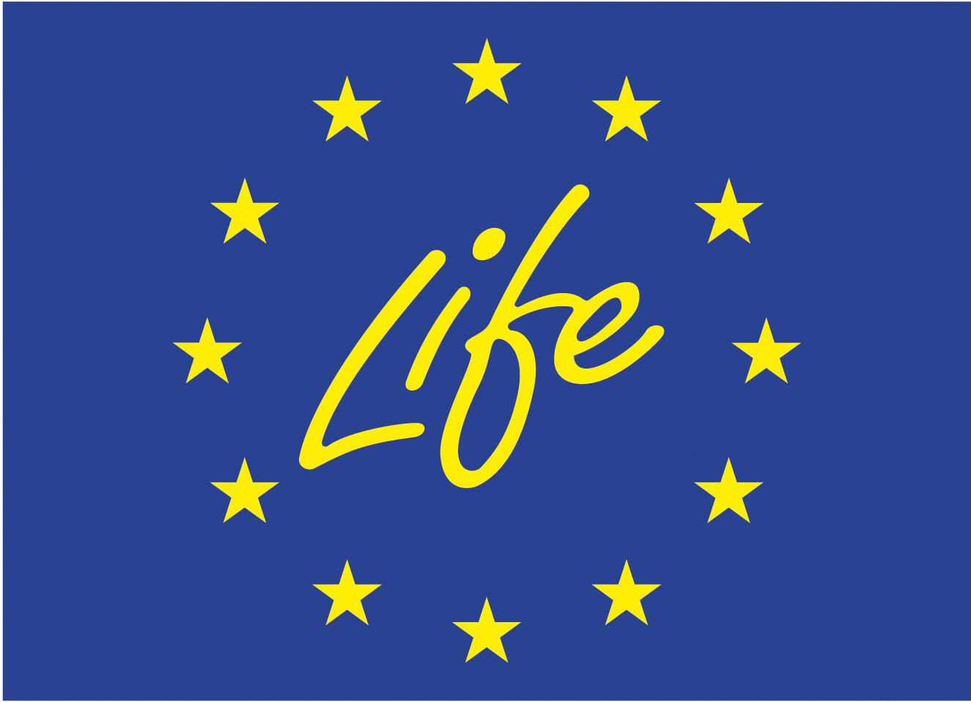
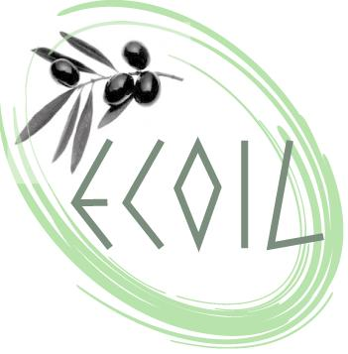
LIFE ENVIRONMENT
life PROJECT 04/env/gr/000110

“Life Cycle Assessment (LCA) as a Decision Support Tool (DST) for the ecoproduction of olive oil (ECOIL)”

PROJECT MEETING
7 June 2006
Department of Production Engineering and Management
Technical University of Crete (TUC)

CHANIA, CRETE, GREECE


MUNICIPALITY DEPARTMENT OF
POLEMARCHI, VOUKOLIES

INVITATION

We kindly invite you to the meeting
of the LIFE programme ECOIL
to be held
in the Park for the Preservation of Flora and Fauna
of the Technical University of Crete
Chania, Wednesday 7th June 2006

We will be honoured by your presence
The programme coordinator
Dr. G. A. Papadakis

LIST OF PARTICIPANTS
# | NAME | AFFILIATION -
Delegates from the European Commission
1 | Mr. Alexis Tsalas | European Commission, Desk Officer for Greece and Cyprus (LIFE Environment & LIFE Nature)
2 | Mrs. Christina Marouli | LIFE ENVIRONMENT Monitoring Expert, MoT Astrale GEIE - Prospect C&S
Delegates from the Technical University of Crete
3 | Mr. Georgios Papadakis | Dr. Chemical Engineer, ECOIL Programme Coordinator Technical University of Crete (TUC)
4 | Mr. Georgios Stayrakakis | Professor Dept. Elect. & Comp. Eng.,  Technical University of Crete
5 | Mr. Andeas Mentzis | Chem. Engineer, Scientific Collaborator  Technical University of Crete
6 | Mr. Konstantinos Kokkinos | Production & Management Engineer  Scientific Collaborator, Technical University of Crete
7 | Mr. Evangellos Vageloglou | Production & Management Engineer  Scientific Collaborator, Technical University of Crete
8 | Ms. Anastasia Chalkidou | Production & Management Engineer  Scientific Collaborator, Technical University of Crete
9 | Ms. Paschalia Machaira | Production & Management Engineer  Scientific Collaborator, Technical University of Crete
10 | Mr. Achilleas Papadopoulos | Dr. Chemical Engineer, Scientific Collaborator  Technical University of Crete
Delegates from the Voukolies Municipality - Polemarchi Region – Oil Production
11 | Mr. Bobolakis | Major of Voukolies Region
12 | Mr. Markos Stefanoudakis | Architect Engineer – Eco farmer  Vice President of Agricultural Cooperative of Polemarchi Municipality dept. of Voukolies (ECOIL partner: AGRIPOL)
13 | Mr. Manolis Anagnostakis | General Manager of TERRA CRETA S.A.
Delegates from the University of Cyprus
14 | Mr. Marios Avraamides | Scientific Collaborator, University of Cyprus (UCY)
Delegates from the Sitia Region, Lasithi, Crete
15 | Mrs. Antonella Psaroudaki | Dr. Agronomist, Technological Educational Institute of Crete, Dept of Nutrition and Dietetics
16 | Reverend Philotheos | Father superior of Toplou Monastery  President of «Ecofarmers S.A.» Sitia, Crete
17 | Mr. Aivaliotakis | Production Manager «Ecofarmers S.A.» Sitia, Crete
18 | Mr. Nikolaos Tsantakis | Union of Agricultural Cooperatives of Sitia  Sales Manager
19 | Mr. Evangellos Petrakis | Olive planter, Union of Eco farmers of Sitia
Delegates from LEIA
20 | Mr. Inaki Laburu | Fundacion LEIA, Centro de Desearrolo Technologico Minano, Spain
21 | Mr. Jorge Molero | Fundacion LEIA, Centro de Desearrolo Technologico Minano, Spain

Meeting Agenda
Project Partners Session
9:00 Welcome – Presentation of Participants
9:15 Short Presentation of General Project Targets and Running Tasks (TUC)
9:30 Presentation of Completed Tasks in Cyprus (UCY)
9:50 Presentation of Completed Tasks in Spain (LEIA)
10:10 Presentation of Completed Tasks in Greece (TUC)
10:30 Discussion – Questions by the Desk Officer and MoT
11:15 Session closure
11:20 Coffee Break
Project collaborators & authorities Session
11:35 Life Cycle Analysis – Major Challenges
11:45 Data from Implementation in Case Studies Regions
12:00 Dissemination Plans for Project Information and Results
12:15 Presentations and Positions of Collaborators
13:00 Discussion
13:30 Meeting Closure – Lunch
Site Visit Session
Afternoon: 1. Visit to the Olive Oil Production and Standardization site TERRA CRETA, Oil production of Polemarchi Region
2. Visit and guided round tour in Polemarchi olive groves region

